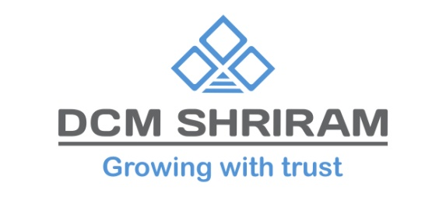

DCM Shriram Ltd signs MoU with Government of Gujarat to invest INR 12,000 Crores by 2028
New Delhi, 4th January 2024: DCM Shriram Ltd, India’s second largest Chlor Alkali manufacturer, signed a Memorandum of Understanding with the Government of Gujarat to invest a proposed INR 12,000 Crore in manufacturing of Chemical and Petrochemicals products in the Bharuch by 2028.
The MoU was signed in a ceremony held at Gandhinagar, Gujarat on 3rd January 2024 in the presence of Hon’ble CM Shri Bhupendrabhai Patel along with other ministers and senior officials from the state government. The ceremony was a part of Vibrant Gujarat Global Summit 2024 which will take place on 10-12th January 2024 in Mahatma Mandir, Gandhinagar, Gujarat.
DCM Shriram currently has significant Chlor Alkali facilities in Bharuch, Gujarat and aims at increasing the existing capacities while adding new products to its Chlor-Alkali portfolio.
The current business portfolio of DCM Shriram spans across multiple sectors including Chlor-Vinyl Business – (Caustic Soda, Chlorine, Aluminium Chloride, Calcium Carbide, PVC Resins, PVC Compounds, Power and Cement); the Agri-Rural Business (Urea, Sugar, Ethanol, Farm Solution Business covering entire range of inputs, R&D based Hybrid Seeds.) and Value Added Business - Fenesta Building Systems which makes UPVC and Aluminium Windows & Doors.
About DCM Shriram Ltd:
DCM Shriram Ltd is a diversified business conglomerate with interests in Agri-Rural, Chlor-Vinyl, and Value-added business. With a rich legacy and a commitment to sustainable practices, the company continues to play a pivotal role in shaping India's agricultural and industrial landscape.

